REPORT WRITING
Course #3300
Participant Handout

Texas Commission On Law Enforcement
Presented by

Bexar County Constable Office PCT#4
Constable Robert M. (Mike) Blount
TRAINING DVISION

Deputy Chief George D. Little, C.C.P.S.,
Primary – Lead Instructor & Mentor
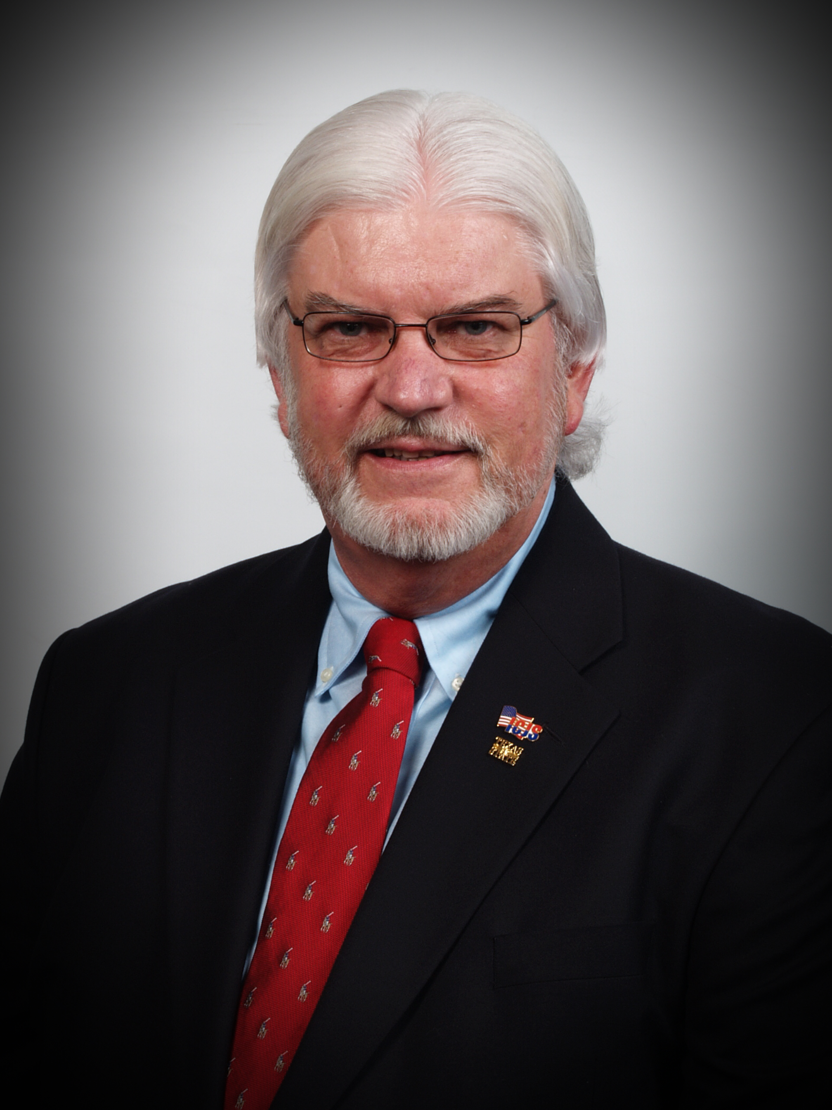 George D. Little, C.C.P.S. – TCOLE Advanced Certified Instructor

George D. Little has 43-years of diverse law enforcement experience, in which he has worked a myriad of assignments working literally in every aspect of law enforcement. He holds an Associate of Science Degree in Criminal Justice from Central Texas College, a Bachelor of Science in Occupational Education Criminology/Sociology from Wayland Baptist College and Associates of Science in Criminal Justice, a Bachelor of Science in Criminal Justice & Criminology and Master’s degree in Criminology and Human Services and Counter-Terrorism from the University of the State of New York. In addition George received his Basic, Intermediate, Advanced and Masters (Peace Officer) Law Enforcement certifications from the Texas Commission On Law Enforcement (TCOLE). George is a retired U.S. Army Military Police (ABN) First Sergeant/E-8 who served his country from Vietnam through Desert Storm for 21-years of honorable service. During his active duty service George served as a Military Policeman (95BV5MXH3 MOS) Patrol, Traffic and Tactical operations. He is a former U.S. Army Criminal Investigations Division (CID) Special Agent and Section Chief Military Police Investigations (MPI). George worked as an under-cover Drug and Narcotics investigator with the U.S. Drug Enforcement Administration (D.E.A.) overseas European operations. He is an experienced veteran Physical Security and Crime Prevention specialist with expertise in Force Protection, and Counter-Terrorism, in addition to being a MP Special Operations Operator (Counter-Terrorism for 1988 Olympics in Seoul South Korea) and a former Military Police School Drill Sergeant and Master Instructor. George served as a Deputy Provost Marshal USFK Area II, South Korea and as a First Sergeant for several MP units ending his military career as the Operations Sergeant (NCOIC) for the U.S. Army Joint Counter Drug Operations Element (JCOE) providing federal, state and local military assistance for an 8-state area of responsibility. He retired from the Bexar County Sheriff’s Office San Antonio, Texas (2008) where he was a Deputy Sheriff, School Resource Officer and the Drug Abuse Resistance Education (D.A.R.E.) Coordinator for Bexar County and was the 2004 National D.A.R.E. Officer-Of-The-Year (and former D.A.R.E. America- Texas D.A.R.E. State Coordinator). George has over 20 years veteran experience working in a school district environment. He has authored and co-authored numerous articles on Counter Terrorism and Law Enforcement serving as a college adjunct professor teaching criminal justice and counter-terrorism undergraduate courses. He has a passion for teaching; in addition to being a Texas Certified Crime Prevention Specialist (C.C.P.S.). George is the former Director of Institute for Criminal Justice Studies (ICJS) – Texas State University where he developed the first comprehensive School-Based Law Enforcement Officer (SBLE) holistic certified training program, a state-wide TCOLE certified Crime Prevention certification curriculum; as well as authored, researched and developed numerous state-of-the art, scientific and researched-based, “Best Practices” specialized law enforcement curriculums. He is currently the Deputy Chief for INTEL, Homeland Security and Training for the Bexar County Constable Office, PCT#4. George was the 2011 TCOLE Professional Achievement Award recipient, and has received numerous U.S. Drug Enforcement Administration Awards and recognitions; recipient of the Federal Bureau of Investigation - Directors Community Leadership Award; and American Society for Industrial Security – Business Crime Council Award. George is an appointed member of the U.S. Department of Justice – National Institute of Justice Technical Working Group for School Safety in addition to being a certified Honorary Tennessee and Kentucky Colonel.

Law Enforcement Report Writing TCOLE # 3300
Instructor's Note:

This lesson has been researched and up-dated to ensure accurate essential knowledge, skill levels are being provided to each participant. Course critiques and participant dialogue are used to enhance and improve knowledge and identify specific areas in which content will improve participants knowledge and skill levels to be more effective to their agency and citizens they serve. George D. Little, C.C.P.S., Deputy Chief, INTEL, Homeland Security (HS) and TRAINING.

Abstract

This instructor guide is designed to meet the educational requirement for Law Enforcement Report Writing Course under TCOLE General Reporting Number 3300 and to be compliant with law enforcement training and education, as set down by the Texas Commission On Law Enforcement identified lesson/course learning objectives.

Target Population: Licensed law enforcement personnel in Texas

Prerequisites: Experience as a law enforcement officer

Length of Course: A suggested instructional time of 5 hours

Material Requirements: True-Touch TV, chalkboard and/or flip charts, video tape player, handouts, practical exercises, and demonstrations

Instructor Qualifications: Instructors should be very knowledgeable about writing law enforcement reports & TCOLE Certified Instructor

Research and content development by: Deputy Chief George D. Little, Dr. YongSok Kim, Captain Arthur Neal Burford, and other subject matter experts recruited by the Bexar County Constable Office PCT#4. Deputy Sheriff Brian Higby BCSO Academy.

Evaluation Process and Procedures An examination and practical exercises will be given along with Define & Process of each learning objective. The instructor may decide upon the nature and content of the examination i.e. written test or Practical Exercise to wit; write a report. It must, however, sufficiently demonstrate the mastery of the subject content by the participant.

Reference Materials
Reference materials are located at the end of the course. An electronic copy of this instructor lesson plan may be provided upon electronic request to the Bexar County Constable Office PCT#4.

DEFINE &
PROCESS
Process:
Define:
DEFINE &
PROCESS
Process:
Define:
DEFINE &
PROCESS
Process:
Define:
DEFINE &
PROCESS
Process:
Define:

DEFINE &
PROCESS
Process:
Define:
DEFINE &
PROCESS
Process:
Define:

DEFINE &
PROCESS
Process:
Define:
DEFINE &
PROCESS
Process:
Define:
DEFINE &
PROCESS
Process:
Define:
DEFINE &
PROCESS
Process:
Define:
Sample Police Report
Case Number: 010147858
Date: 13 August 2015
Reporting Officer: Deputy Jones
Prepared By: CPL Stevens
Incident Type: Robbery

Address of Occurrence: 557 Maple Street, Manchester, NH 03104

Witnesses:
Alan Perez: Store owner. Male, 43, Latino
Michael Tully: Employee. Male, 21, African American
Andrea Chao: Customer. Female, 27, Asian American

Evidence:
Closed-circuit surveillance footage
Fingerprints (taken from counter)
Footprint (size 10 Nike Air, found in drying paint)
Weapon/Objects Used: Pistol/Firearm

Preliminary Investigation:
On August 13, 2013, at approximately 17:38, two unidentified males entered a 7-Eleven convenience store and stole $232 from the register at gunpoint. The store’s security camera recorded the incident as one man pointed a handgun at store owner Alan Perez while the other man gestured threateningly while demanding that Perez give him the money from the register. “Two guys came in with masks and a gun,” Perez said in his witness statement, “and one started yelling at us to give him the money.” Perez was running the store with the help of Michael Tully, his employee. Tully described the suspects as middle-aged, white, both wearing leather jackets, jeans, and ski masks. The only customer in the store was Andrea Chao, who heard the robbery taking place but did not see it as she was in the store restroom at the time.
After obtaining the money from the register, the two suspects ran out of the store. The parking lot had been painted earlier that afternoon, and Perez identified one of the suspect’s footprints in the drying paint.
Sample Police Report-Cont’d: Deputy Jones arrived on the scene at around 18:15, responding to Perez’s 911 call. After reviewing the security footage, Deputy Jones noticed that the unarmed suspect had at one point leaned across the counter as he was grabbing money from Tully and Perez. Fingerprints were captured from the counter and sent to the forensics lab for analysis. Closer inspection of the drying shoeprint revealed that one of the suspects was wearing size 10 Nike Airs, which is consistent with the security footage.

Final Test – Practical Exercise

Time Dispatched: At this time

Date: Todays Date Case# 15-154923

12345 Anywhere Street, San Antonio, Texas

Witness One: Bart Star-05-22-1990 12350 Anywhere, saw this Mexican guy coming from inside John Doe’s house and running down the street.

Witness Two: Heard 2-Pop-Pop sounds then saw a Mexican Male about 26 – 30 years of age, about 5’11” running out of John Doe’s house. Nosey Phillips, DOB:07-04-1989, 35412 Anywhere.

Witness Three (Next door Neighbor): Heard John Doe arguing with some guy, then heard two bangs and I saw some guy Mexican I think wearing a red shirt and blue jeans running North down Anywhere Street after he exited John Doe’s house. I Saul Everything, DOB: 12-22-1993, 12346 Anywhere

Witness Four (Teenager riding a bicycle) identified at Iam Text Masters, DOB: 03-08-2002 15421 Anywhere

John Doe dead inside his home shot twice in chest, blead out, furniture was knocked over.

You get there and find door open you call out and no response you open the door a little more with your clipboard. You can plainly see a body lying on the living room floor with a broken light, turned over coffee table and smashed chair, the lights were on witness one and two run up to you and state (See their responses above) You also see two 9mm bullet casings laying on floor. You check the body and do not find a pulse. Doe has two red marks on his cheek looked like someone punched him. You find a wallet in John Does right hand and it contained John Doe’s Tx Driver’s license 98765432, a Visa Card and a Master Card along with four (4) $100.00 bills, five (5) $20.00 bills, three (3) $10.00 and two (2) $5.00 bills. As you start to exit witness three approaches you and tells you his statement (See above) and as he is talking he suddenly points across the street and says there he is that is the man I saw running from John Does house, quickly the other two exclaim that’s him. You see unit 20 Deputy Constable John Brown pulling up and tell him that is the suspect running away from the scene he turns around and pursues him. You separate the witness and tell them to stay there after collecting their ids. You call in what you have so far and start taping off crime scene. CID arrives and released the scene to them. You also hear on radio that Unit 20 and Unit 32 had taken suspect into custody. You start going over crime scene with CIS Joshua Vasquez SAPD CID when unit 20 drive up and all three witnesses start saying that’s the man (Wit One), one says that is the son-of-a-bitch that shot John Doe (wit Two), and the Neighbor says that is the man I saw running from John Does house just after I heard Bang-Bang. You also notice a knife sticking in wall right by front door to Doe’s home. This all happened in 15 to 20 minute intervals. EMS came by and EMS Bob Kildare said the victim was dead. You then heard CID Vasquez calling and asking for county corner. DC John Brown also tells you that Xavier Perez Dominguez who is wearing blue jeans and a white sleeveless V-neck t-shirt, was name of suspect and he (Dominguez) said to him that Doe had threw a knife at him and so he shot him once and ran out the door. DC Brown also said he found $500.00 in hundred dollar bills and an American Express Card in the name of John Doe (victim). Dominguez also stated to Brown that Doe owed him some money, he went to collect $500.00 from him (Doe) and they started arguing with Doe saying he did not believe the work he (Dominguez) did for him (Doe) was worth $500.00 and so a fist fight broke out. He said he took the money heard John Doe say “you crooked Mexican” and when he turned around Doe threw a knife at him and so he shot Doe. Dominguez said he fled taking off his red shirt and throwing it into some bushes as he fled. Dominguez also said that he (Dominguez) threw away his 9mm when police was chasing him. A young teenager riding a bicycle 45-minutes later shows up and hands you a Beretta 9-mm pistol stating he found this alongside the walk way in front of 12353 Anywhere street.

Now File your Report

